

**INTERNATIONAL CULTURAL FESTIVAL 1 DAY**

Culture is an umbrella term which encompasses the social behavior, institutions, and norms found in human societies, as well as the knowledge, beliefs, arts, laws, customs, capabilities, and habits of the individuals in these groups. Culture is often originated from or attributed to a specific region or location. The Kenya National Library Service Buruburu in partnership with Utamaduni Ngomas hosted the annual Cultural day Festival at the Kenya National Library Services in Buruburu, Nairobi on **May 21 2020.**

**OBJECTIVES OF CULTURAL EVENT**.

* To respect and appreciate cultural diversity.
* To promote the understanding of unique cultural and ethnic heritage.
* To promote the development of culturally responsible and responsive curricula.
* To facilitate acquisition of the attitudes, skills, and knowledge to function in various cultures.
* To eliminate racism and discrimination in society.
* To achieve social, political, economic, and educational equity.

The festival kicked off on May 21 at the Kenya National Library Service in Buruburu, Nairobi with the librarian welcoming the storytellers from Nairobi and other parts of the country . The librarian also welcomed the audience that comprised of mainly children from the invited schools around Buruburu area which included:

1. Kenya Muslim Academy.
2. Utamaduni Ngomas.
3. Sunshine Junior Academy.

The attendance came in expected numbers, being welcomed in warmly manner by being given sweets.

**PICTORIALS**

Images of the pupils, teachers and other audience enjoying the traditional dances as they dance along, doing hands on activity of making a camera using pieces of papers being guided by the facilitators and also listening keenly to the traditional African stories.

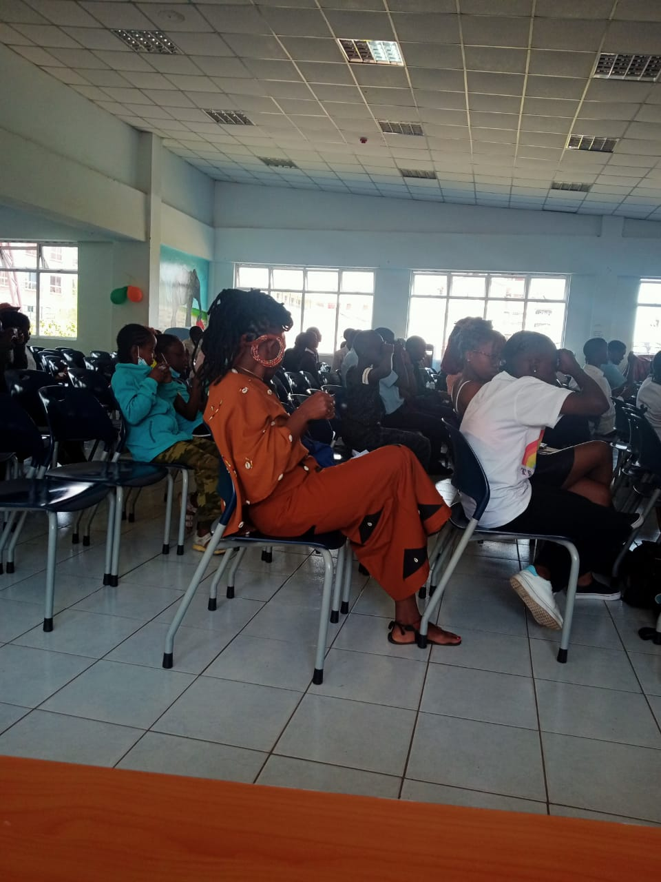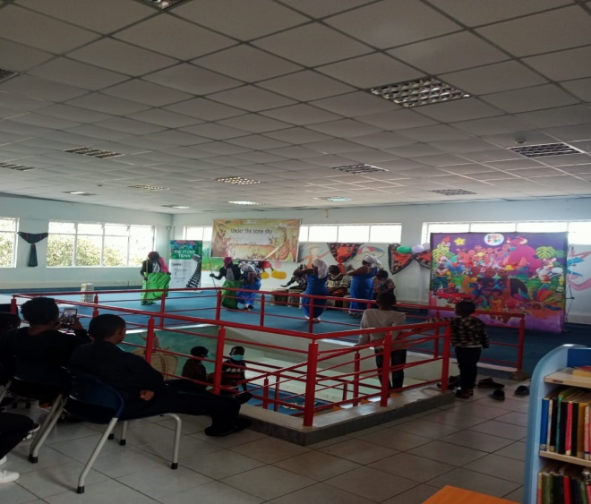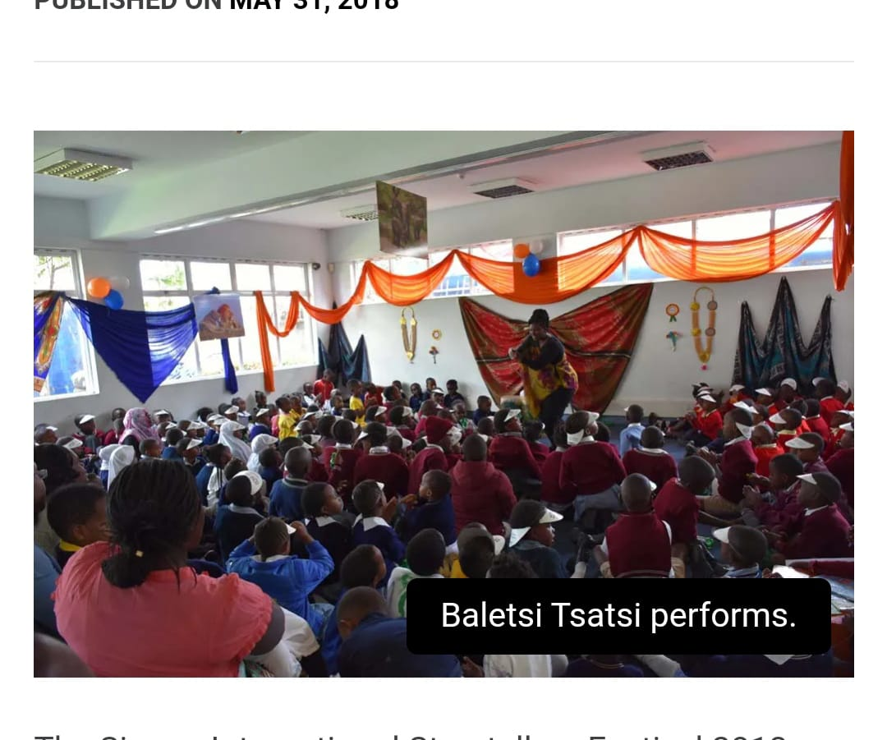

**ADVANTAGES OF CULTURE**

* Tradition contributes a sense of comfort and belonging. It brings families together and enables people to reconnect with friends.
* Tradition reinforces [values](https://www.franksonnenbergonline.com/blog/times-may-change-but-your-core-values-dont/) such as freedom, faith, integrity, a good education, personal responsibility, a [strong work ethic,](https://www.franksonnenbergonline.com/blog/hard-work-is-good-for-your-soul/) and the value of being selfless.
* Tradition provides a forum to showcase role models and celebrate the things that really matter in life.
* Tradition offers a chance to say “thank you” for the [contribution that someone has made.](https://www.franksonnenbergonline.com/blog/whos-your-hero/)
* Tradition enables us to showcase the principles of our Founding Fathers, celebrate diversity, and unite as a country.
* Tradition serves as an avenue for [creating lasting memories](https://www.franksonnenbergonline.com/posters/moments-of-a-lifetime/) for our families and friends.
* Tradition offers an excellent context for meaningful pause and reflection.

**CONCLUSION**

In addition to its value, culture provides important social and economic benefits. With improved learning and health, increased tolerance, and opportunities to come together with others, culture enhances our quality of life and increases overall well-being for both individuals and communities.